Lab4: Inferential Statistics

Student Number: 041273681
Student Name: Olamilekan Elegbede
Using Lab4.ipynb file answer the following Questions. Submit the word document with screenshots and answer to each question

Sample Output:
Q1: Univariate Analysis
Compute summary statistics (mean, median, min, max, std) for NetWorth and Age. Identify the youngest and oldest billionaires.
Sample Output:
First Show your Notebook Code with your name
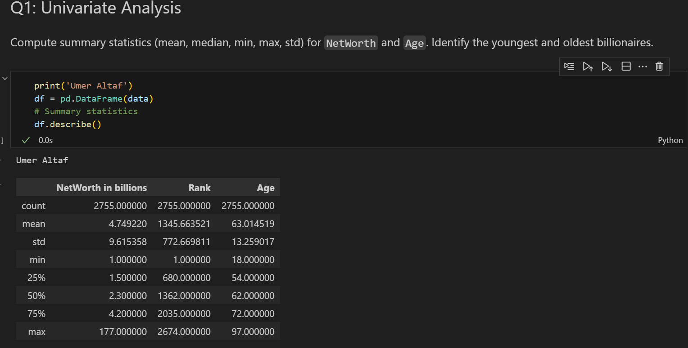

Q1. 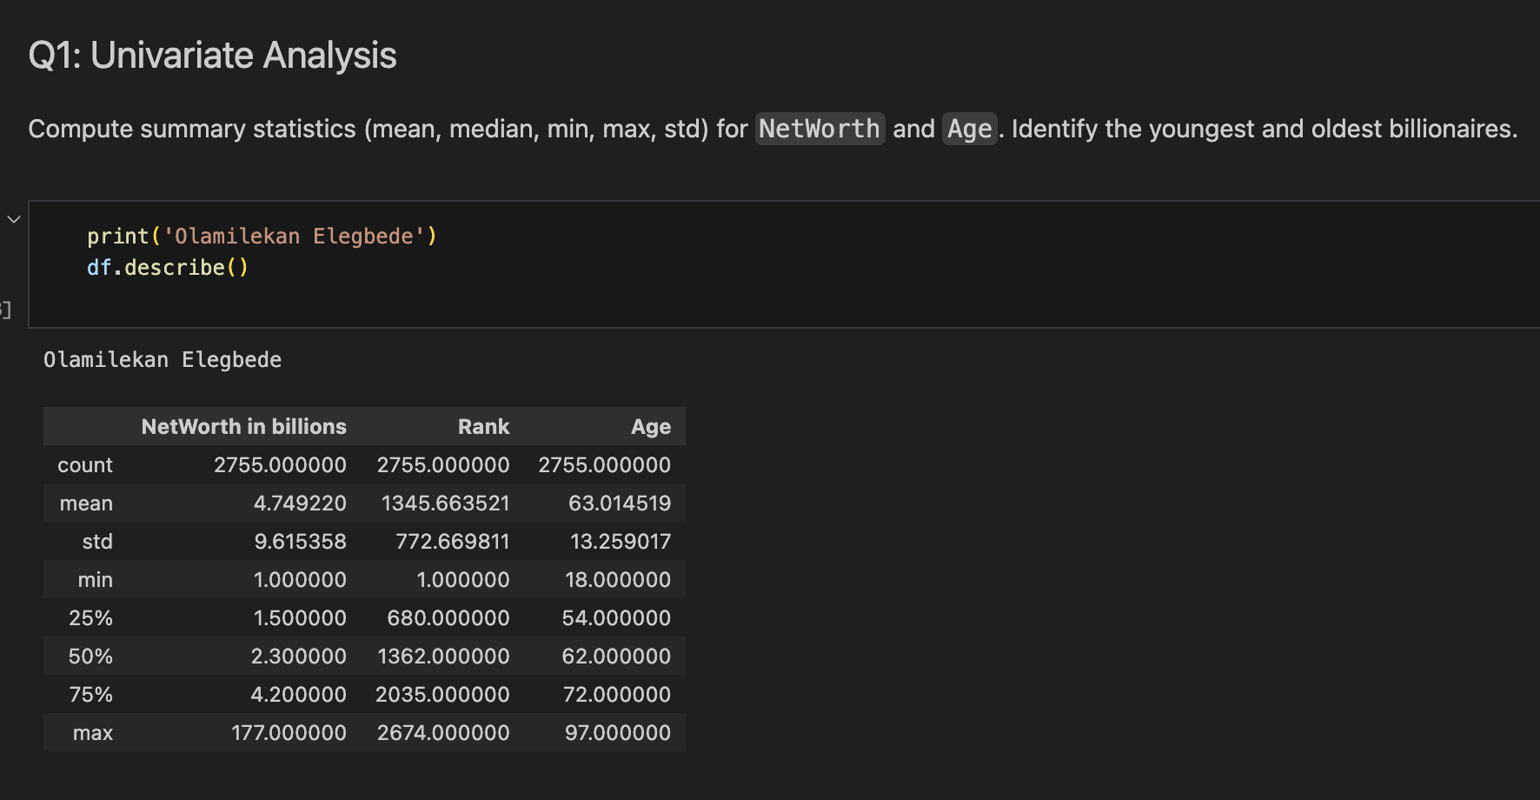
Q2.
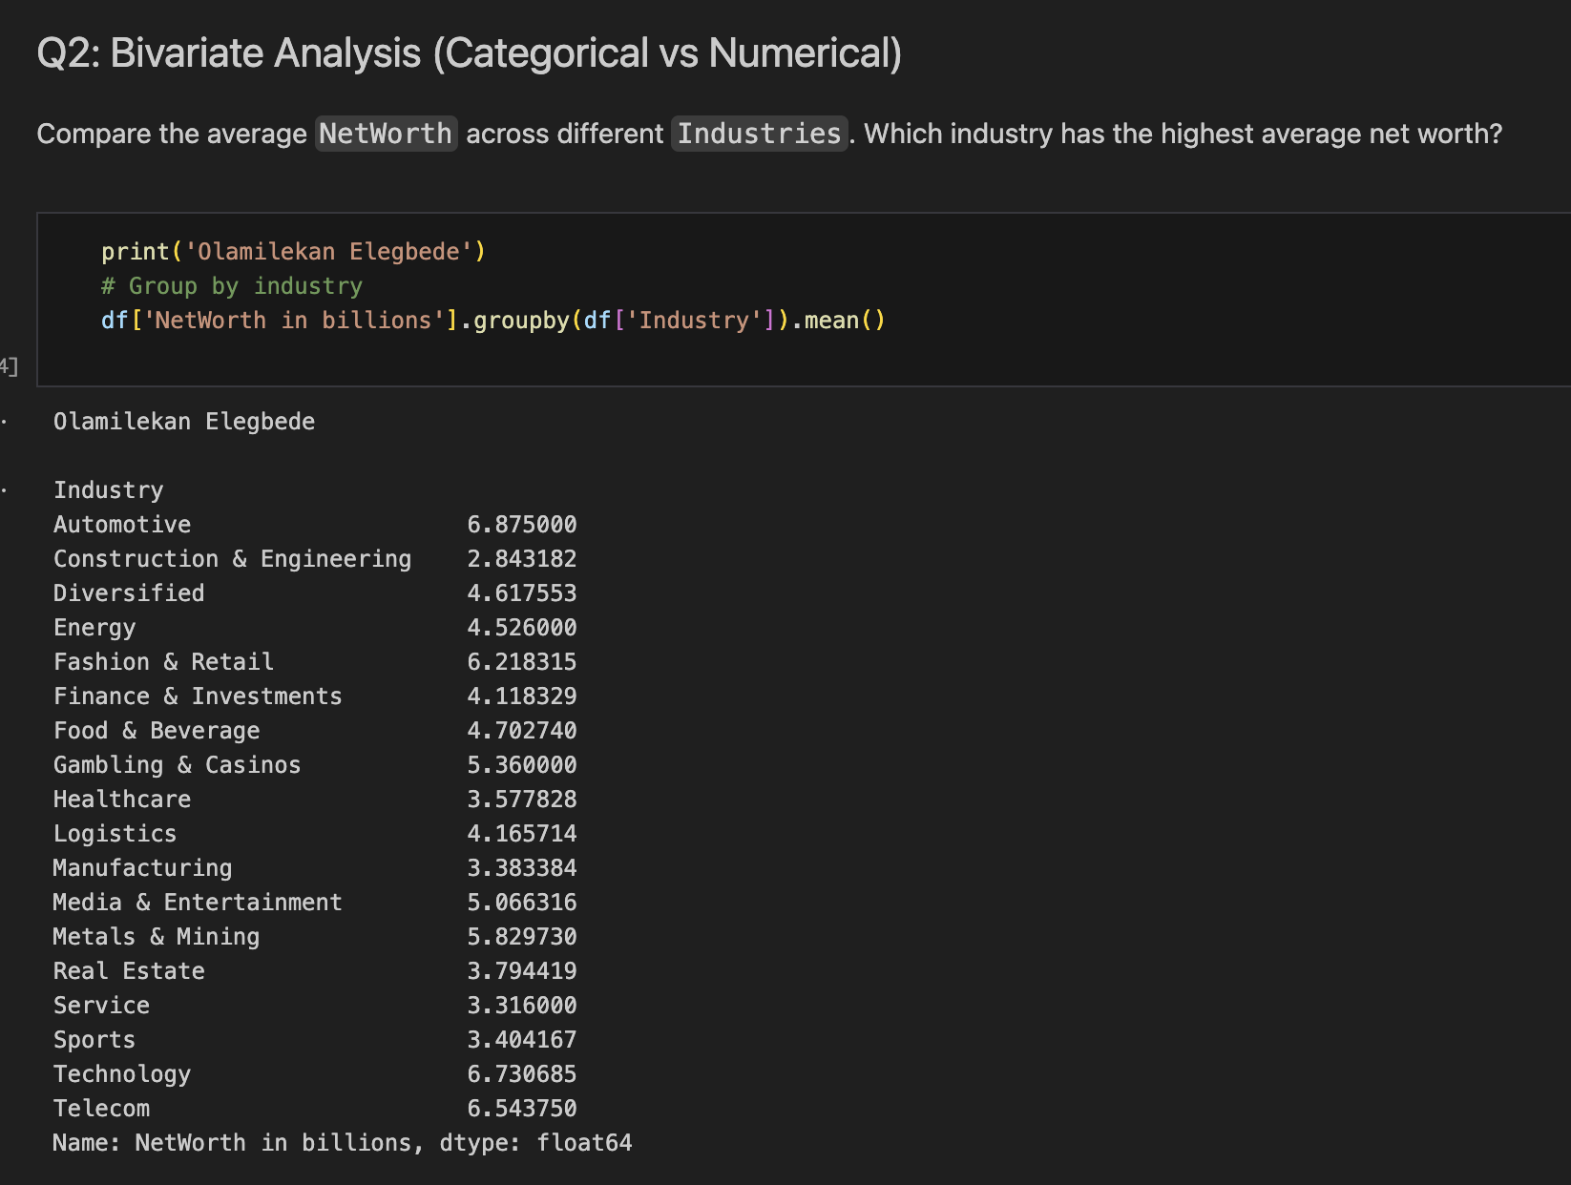
Q3.
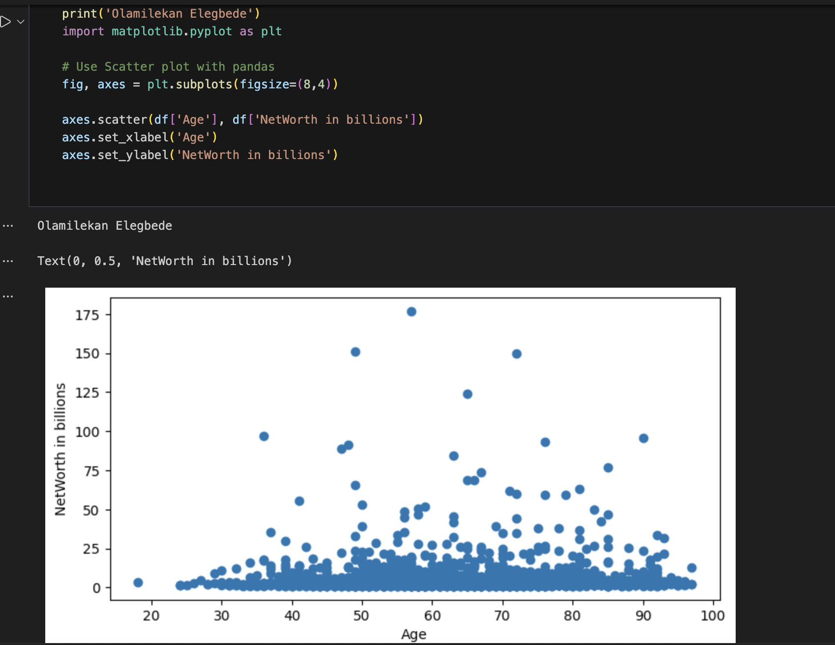

Q4.
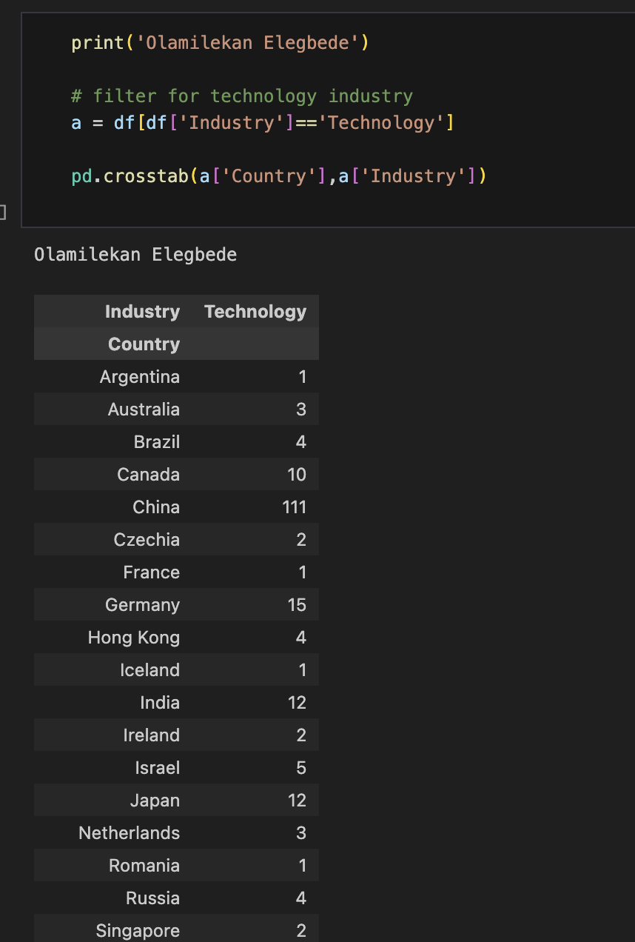
Q5. 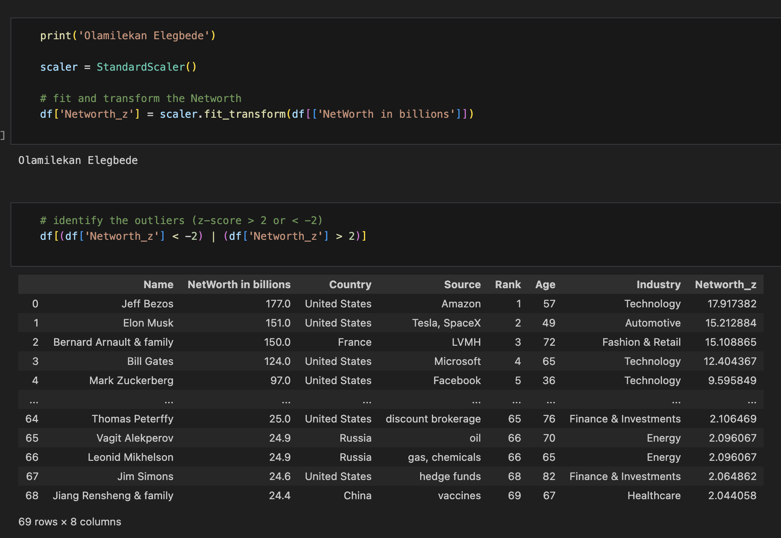
Q6.
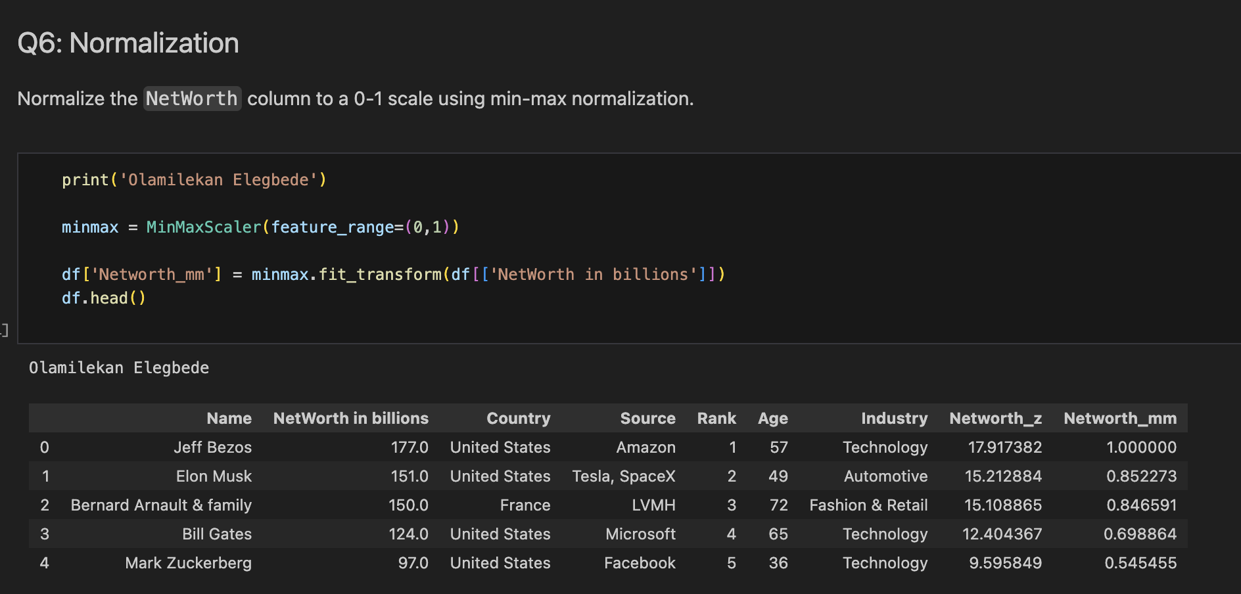
Q7. 